Name of Student: Husam Ali Abdalla Nour | PRN:25070122086
Semester: III | Year : AY 2026-27
Subject: Programming with Java
ASSIGNMENT No : 12
TITLE : User-Defined Packages
Problem Statement
Write a Java program to create and use user-defined packages.
Learning Objectives
To create and use user-defined packages for organizing Java programs.

Programme
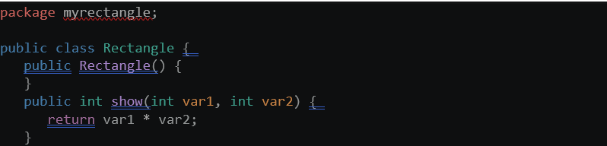
Package1:square(it is not in the same folder with main function nor with my rectangle)
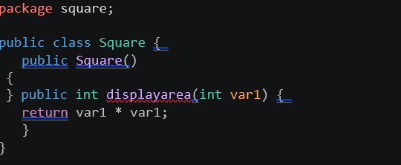
Package2:myrectangle(it is not in the same folder with main function)
Main function(import packages
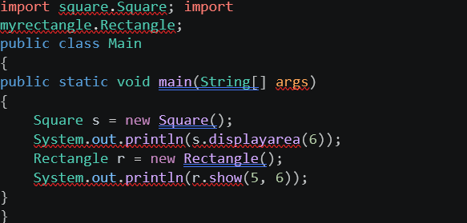
Output
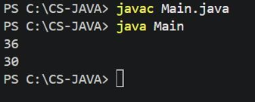
Conclusion
In conclusion, this program demonstrates the use of Java packages and interfaces between classes. The Square and Rectangle classes are placed in separate packages and are imported into the Main class. The program successfully creates objects from both packages and calculates the area of a square and a rectangle.

